**Kaggle Learn**

**1. Intro to Programming**

**1.1 Arithmetic and Variables**

**PEMDAS (order of operations):**

**Variables names rules:**

**1.2 Functions**

**1.3 Data Types**

When you multiple an integer or float by a boolean with value True, it just returns that same integer or float (and is equivalent to multiplying by 1). If you multiply an integer or float by a boolean with value False, it always returns 0. This is true for both positive and negative numbers. If you multiply a string by a boolean with value True, it just returns that same string. And if you multiply a string by a boolean with value False, it returns an empty string (or a string with length zero).

When you add booleans, adding False is equivalent to adding 0, and adding True is equivalent to adding 1.

**1.4 Conditions and Conditional Statements**

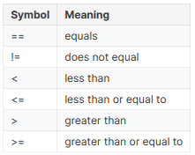

**1.5 Intro to Lists**

You can also pull a segment of a list (for instance, the first three entries or the last two entries). This is called slicing. For instance:

* to pull the first x entries, you use [:x], and
* to pull the last y entries, you use [-y:].

**2. Python**

**2.1 Hello, Python**

a % b example (the modulo operator):

**2.2 Functions and Getting Help**

Use the help() function to get information on some function:

Docstrings or comments in your own functions:

The print() function has a special feature sep that specifies a separator between values. If you don’t specify a separator your values will be separated by spaces.

Calling functions on functions:

**2.3 Booleans and Conditionals**

Function that checks if a number is odd:

**2.4 Lists**

Swapping two variables:

**2.6 Strings and Dictionaries**

Important uses of the backslash character:

**3. Intro to SQL**

**3.1 Getting Started With SQL and BigQuery**

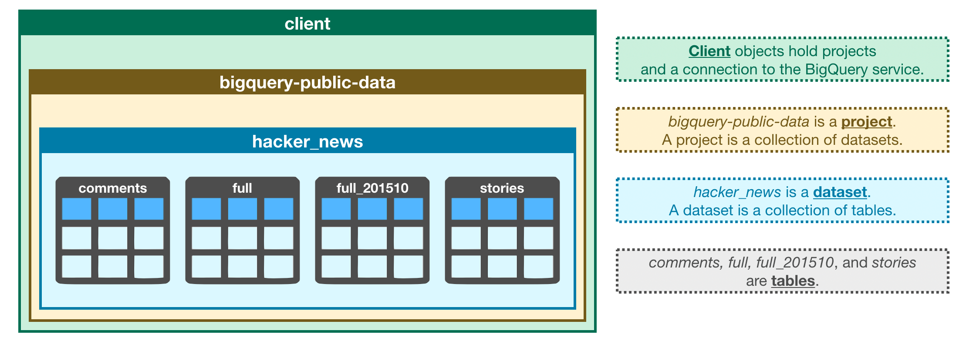

Use this code to fetch a dataset from BigQuery:

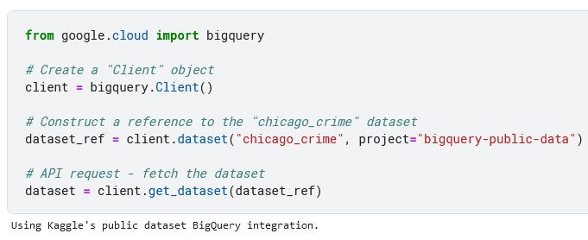

**3.3 GROUP BY, HAVING & COUNT**

When using GROUP BY with COUNT you can use COUNT(1) to count the rows in each group.

**4. Advanced SQL**

**4.1 JOINs and UNIONs**

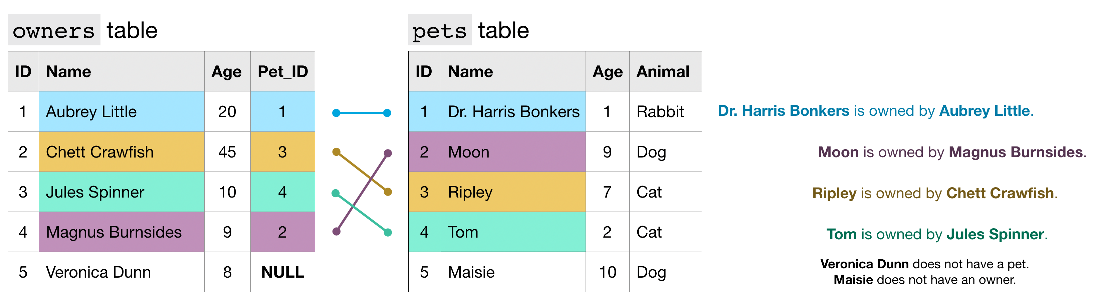

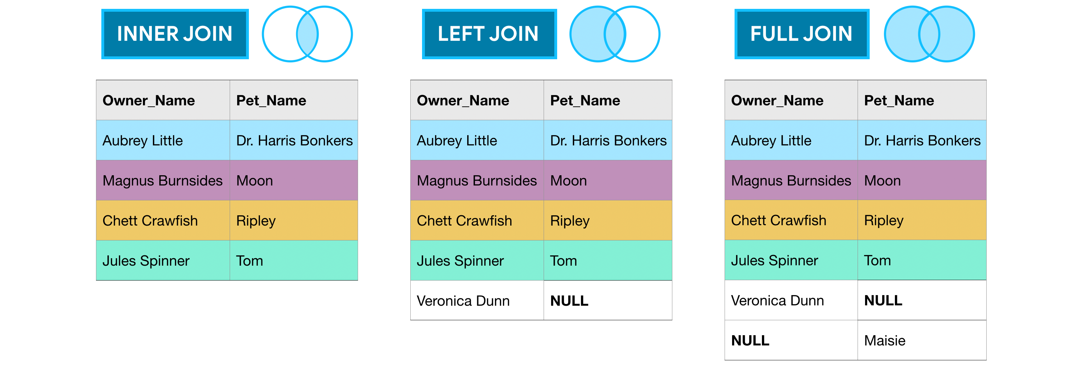

Use UNION ALL to place the second table below the first, use UNION DISTINCT if you want to remove duplicate values.

**4.2 Analytic Functions**

Example of a moving average:

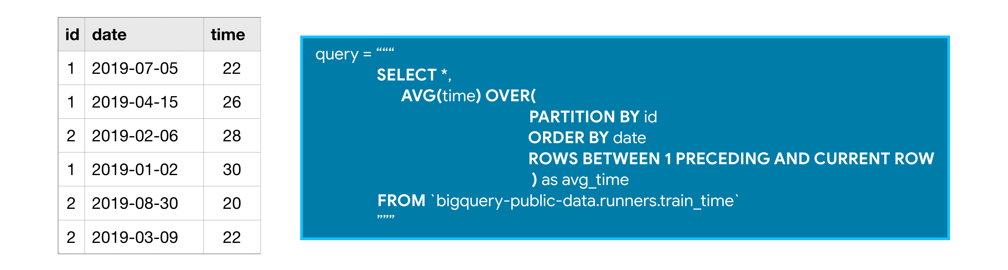

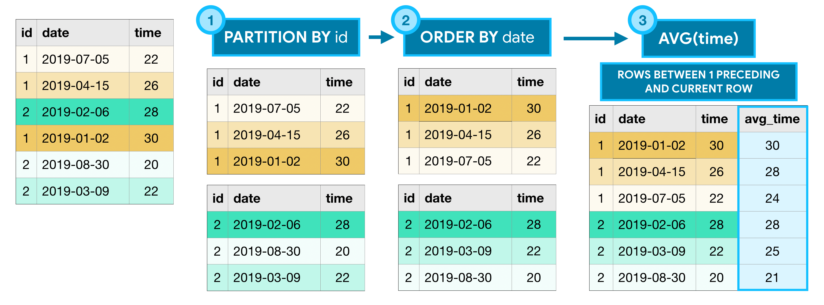

**Google Cloud documentation on** [**Window functions**](https://cloud.google.com/bigquery/docs/reference/standard-sql/window-function-calls)**.**

Calculating the cumulative (cumsum) number of trips per day:

Track beginning and ending station on October 25, 2025 for each bike:

**4.3 Nested and Repeated Data**

**Nested data (datatype STRUCT or RECORD):**

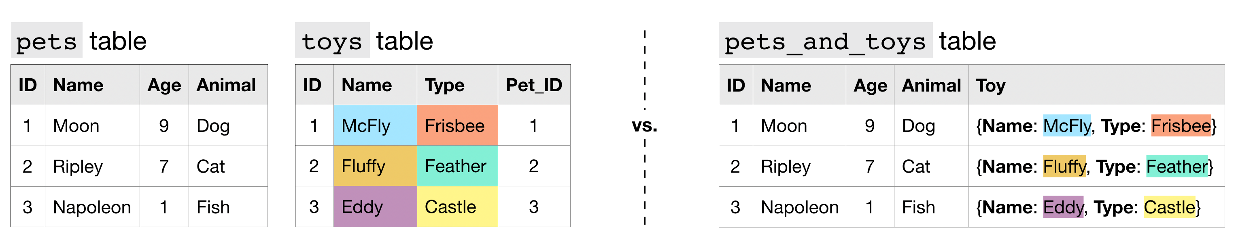

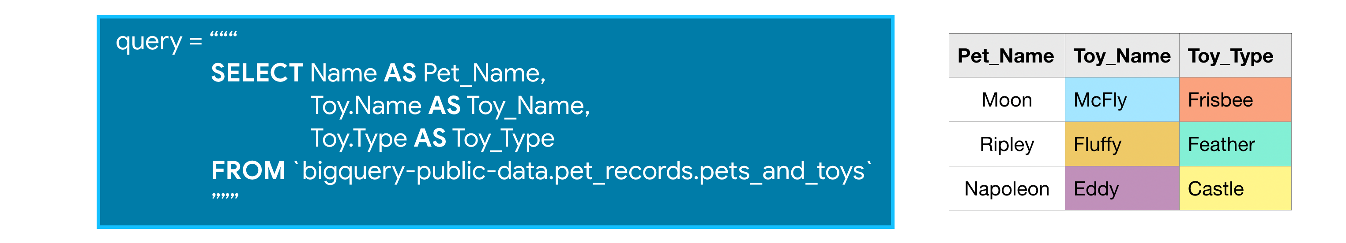

**Repeated data (datatype REPEATED):**

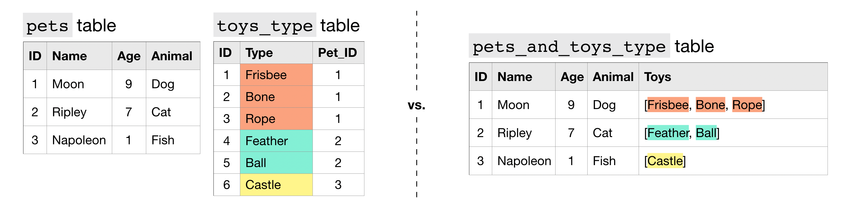

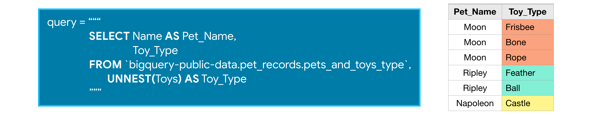

**Nested and repeated data:**

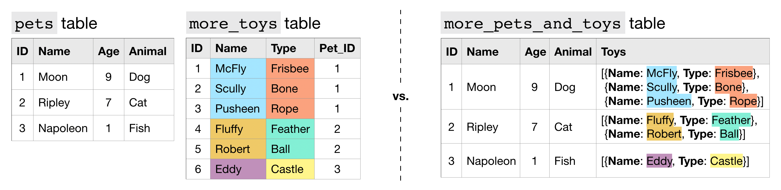

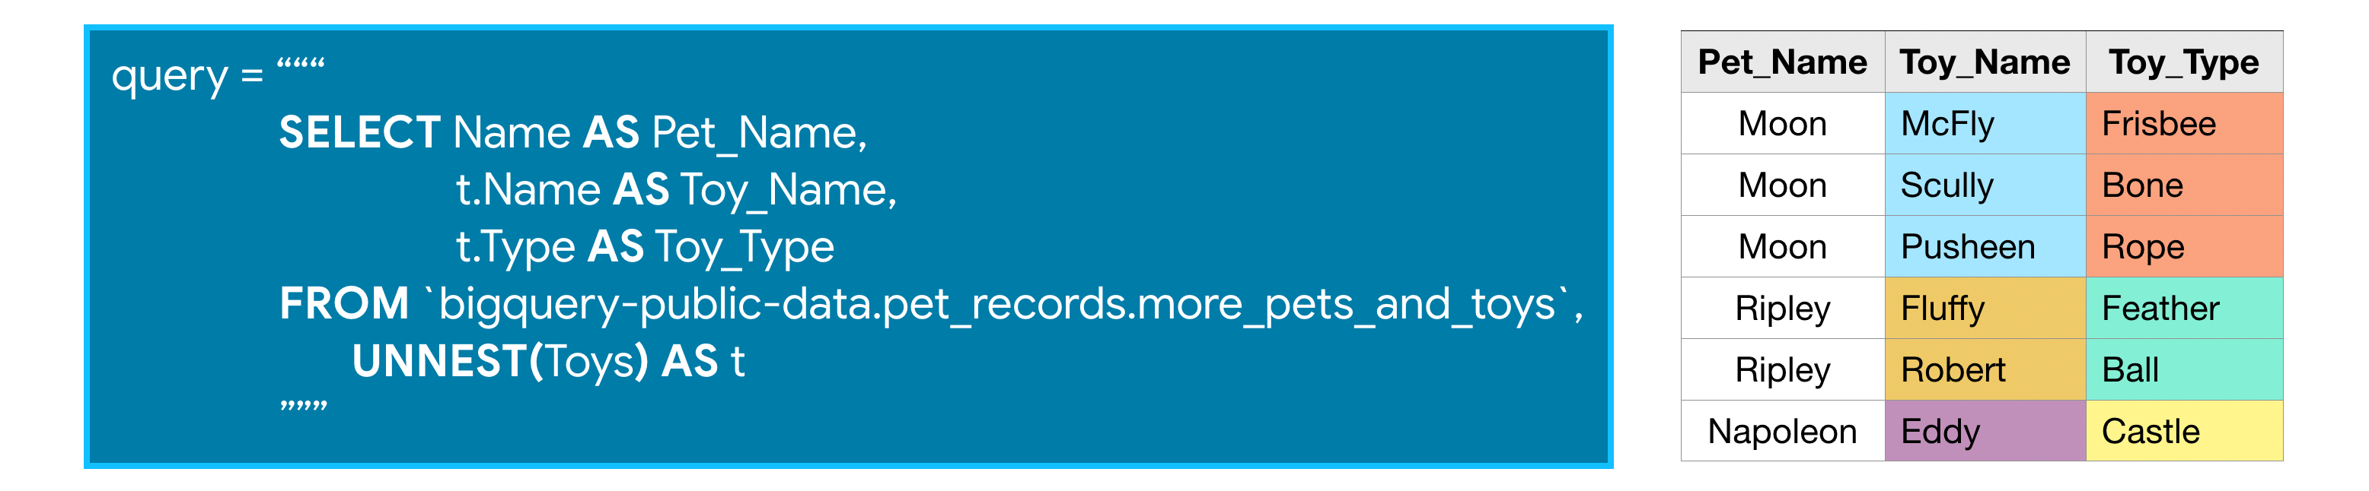

Unnesting example:

**4.4 Writing Efficient Queries**

1. Only select the columns you want;
2. Read less data;
3. Avoid N:N JOINs (many to many connections).

**5. Pandas**

**5.3 Summary Functions and maps**

To subtract a mean value from a column you can use the .map() function:

Or .apply():

Or the pandas functional:

You can also combine columns this way:

